Lab Assignment 1:
Basic Linux Usage and Virtual Machine Setup

Cliff C. Zou
University of Central Florida

- Virtual Machine Setup and Networking between VMs:
Please install VirtualBox on your own machine, then import the following two VM images in your VirtualBox: Kali Linux VM, and Windows 7 VM (with any version of IE you want).
1). Set up these two VMs in “Nat Network” mode and put them in one LAN so that they can reach each other. What are these two VMs IP addresses? Please use screenshot images to show how you know each VM’s IP address.
2). Use screenshot images to show that you can Ping from Win7 VM to your Kali Linux VM successfully, and Ping from your Kali Linux to your Win7 VM successfully.

- Linux Basic Usage: file and directory:
In your Kali Linux VM, login with the ‘root’ account. Then conduct the following operations. All operations must be conducted under Linux command line terminal window:
1). Under your account home directory ‘/root’, create the following directory tree. Use screenshot image to show how you do it.
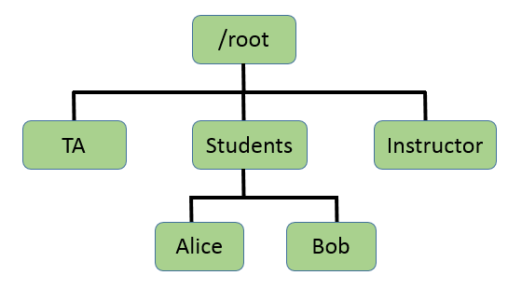
2). Change the directory access property: Make the dir ‘TA’ to be read/write/executable by group and others; make the dir ‘Instructor’ to be un-readable and un-executable by others. Use sceenshot image to show your operations.
3). Copy ‘/etc/passwd’ file under the ‘Alice’ directory. Then use one command line operation to show only the several lines in the passwd file under the Alice directory that contain ‘systemd’ keyword. Again use screenshot image to show your operation.

- Kali Linux Basic Usage:
In your Kali Linux virtual machine, you should be able to find the file ‘password.lst’ under the directory ‘/usr/share/john/’. This is a small dictionary that attacker may use to guess a user’s password.
1). Use screenshot image to show how you know the number of possible passwords contained in this file (don’t count the few comment lines at the beginning of the file)?
2). Show the list of passwords that contain the string ‘1234’ (use screenshot image). And how many of them can you find?

